Network Design Document

Reference Pic. 1 The button “Host Lobby” let the user open a new panel to adjust the server settings. “Join Lobby” instead opens a panel where the user needs to put in the server address.
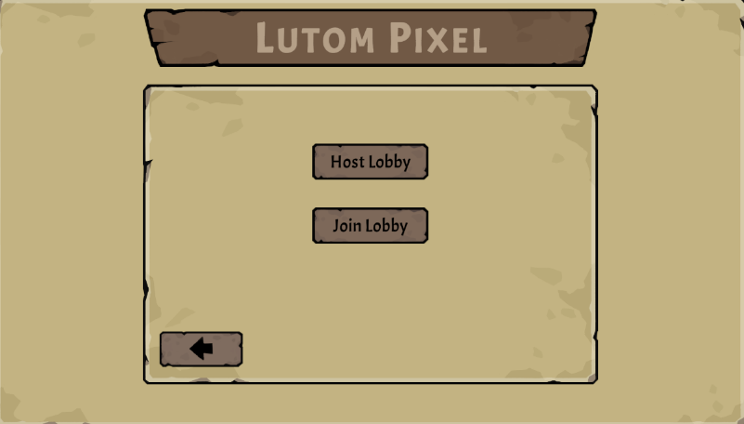

Screenshot (In Game) 1 - Main menu

Reference Pic. 2 In this window the user can adjust the minimum player amount, the Game mode which will played and the level of the match. After everything is set up the user can start the server and open the lobby by clicking “Host”.
Reference Pic. 3 The user can join a server after typing in an IPv4-Address and click “Confirm”.
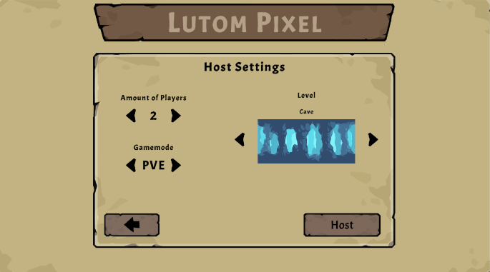
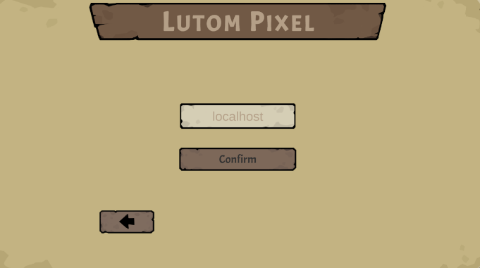
Screenshot (In Game) 4 - Host Lobby Display

Screenshot (In Game) 2 - Host Settings
Screenshot (In Game) 3 - Join IP Panel
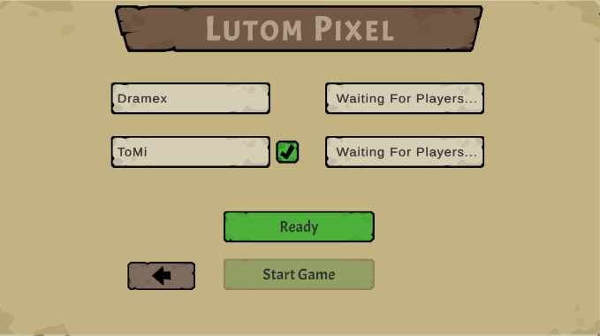
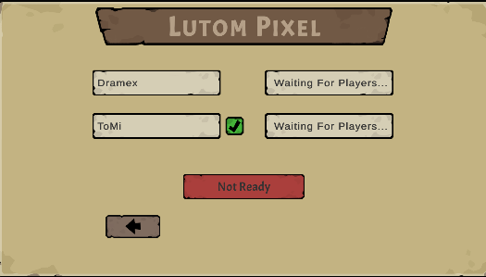
Reference Pic. 4 Host is also able to get ready and if all players in lobby are ready the
user (Server) can start the game, Reference Pic. 5 The view of a joined client.
Screenshot (In Game) 5 - Client Lobby Display
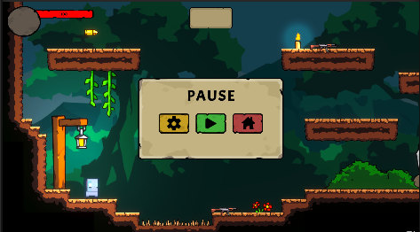
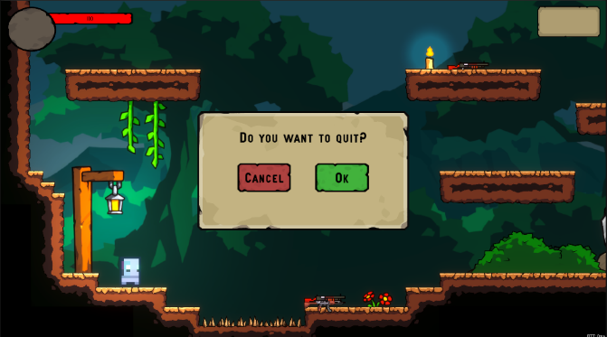
Reference Pic. 5 & Reference Pic. 6 The user is able to pause and leave the game anytime.
Screenshot (In Game) 6 - Pause Menu
Screenshot (In Game) 3 - Quit Menu

